## 期中考试参考答案

S → +id FIRST()= +

⇒FIRST(S)= {+,-,(}

S → -Q FIRST()= -

FOLLOW(S)={$}

FOLLOW(T)={+, -}

FOLLOW(N) ={+, -}

FOLLOW(P)={$}

FOLLOW(Q) ={$}

FOLLOW(E) +=FOLLOW(Q)={+, -, ×, $}

S → TP FIRST()= (

T → E N FIRST()= (

N →× T FIRST()=×

⇒FIRST(N)= {×, ε}

N →ε FIRST()=ε

P →+E FIRST()= +

⇒FIRST(P)= {+,-}

P → -Q FIRST()= -

Q→E FIRST()= (

⇒FIRST(Q)= {(, id}

Q→id FIRST()= id

E → (id) FIRST()= (

LL(1)预测分析表

|  |  |  |  |  |  |  |
| --- | --- | --- | --- | --- | --- | --- |
|  | + | - | × | id | ( | ) |
| S | S → +id | S → -Q |  |  | S → TP |  |
| T |  |  |  |  | T → E N |  |
| N | N →ε | N →ε | N →× T |  |  |  |
| P | P →+E | P → -Q |  |  |  |  |
| Q |  |  |  | Q→id | Q→E |  |
| E |  |  |  |  | E → (id) |  |

1. I0
2. S'→•S
3. S →•M id
4. S →•TME
5. S →•−E
6. S →•T-id
7. T →•E × T
8. T →•E
9. E →•( id )
10. M → •+
11. M → •−
12. I4
13. T → E• × T
14. T →E•
15. I1

S'→S•

1. I8
2. S →M id•
3. I13
4. S →TME•
5. I9
6. S →TM•E
7. E →• ( id )
8. S
9. $
10. E
11. I5

E→ (•id)

1. I10
2. S →T-•id
3. M → −•
5. I11
6. T → E ×• T
7. T → •E × T
8. T →•E
9. E →• ( id )
10. I6
11. M→ +•
12. E
13. (
14. -
15. +
16. I2
17. S →M• id
18. M
19. id
20. I3
21. S →T•ME
22. S →T•-id
23. M → •+
24. M → •−
26. E
27. -
28. T
29. I7

S →−•E

M→ -•

E→• (id)

1. +
2. M
3. ×
4. I12
5. E→ (id•)
6. id
7. I14
8. S →T-id•
10. id
11. I15
12. T → E × T•
13. T
14. (
15. I16
16. E→ (id)•
17. )
18. Accept
19. (
20. I17

S →−E•

E

(

FOLLOW(M)={id, ( };

FOLLOW(E)={+, -, ×, $};

FOLLOW(T) ={ +, - };

FOLLOW(S)={$};

LR(0)的DFA

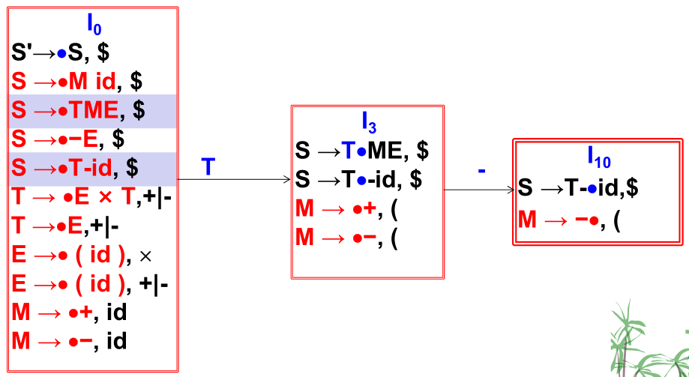

-

1. I7

S →−•E, $

M→ -•, id

E→• (id), ×|+|-

在I10状态，在向前看符号为(时规约，为id时移入，它们不存在交集，因此是规范LR(1)文法；

2. 回文： P= 0 P 0 | 1 P 1 | 2 P 2 | 0 | 1 | 2

3.

1

0

2

1

3

0

4

0

0

0

ε

ε

ε

5

ε

ε

ε

S0= ε-CLOSURE({0}) = {0,1,2,3,4,5}

ε-CLOSURE(Move(S0, 0)) = ε-CLOSURE({1,2,4,5}) = {1,2, 4,5} = S1,1

ε-CLOSURE(Move(S0, 1)) = ε-CLOSURE({3}) = {0,1,2, 3,4,5} = S0

ε-CLOSURE(Move(S1,1, 0)) = ε-CLOSURE({2, 5}) = {2, 5} = S2,1

ε-CLOSURE(Move(S1,1, 1)) = ε-CLOSURE({3}) = {0,1,2, 3,4,5} = S0

ε-CLOSURE(Move(S2,1, 0)) = φ = S3,1

ε-CLOSURE(Move(S2,1, 1)) = ε-CLOSURE({3}) = {0,1,2, 3,4,5} = S0

于是，得到的DFA如下图：

S0

0

1

1

S1,1

0

S2,1

0

S3,1

1

是最简DFA